**CS522_H_HW_4A_Surampudi Venkata Ganesh Swamy Narayana_17939sv**

Test NPU Web‐page using Junit setup and its integration with Eclipse.

1. launch browser (Firefox)

2. Go to <http://google.com>

3. maximize the browser window

4. type NPU in the search text

5. wait until the search result appears

6. find and click the search result link text Northwestern Polytechnic University to open NPU homepage

7. wait until NPU home page loaded

8. click a button or drop down menu to open a sub webpage of NPU, go back to homepage 9. close web browser

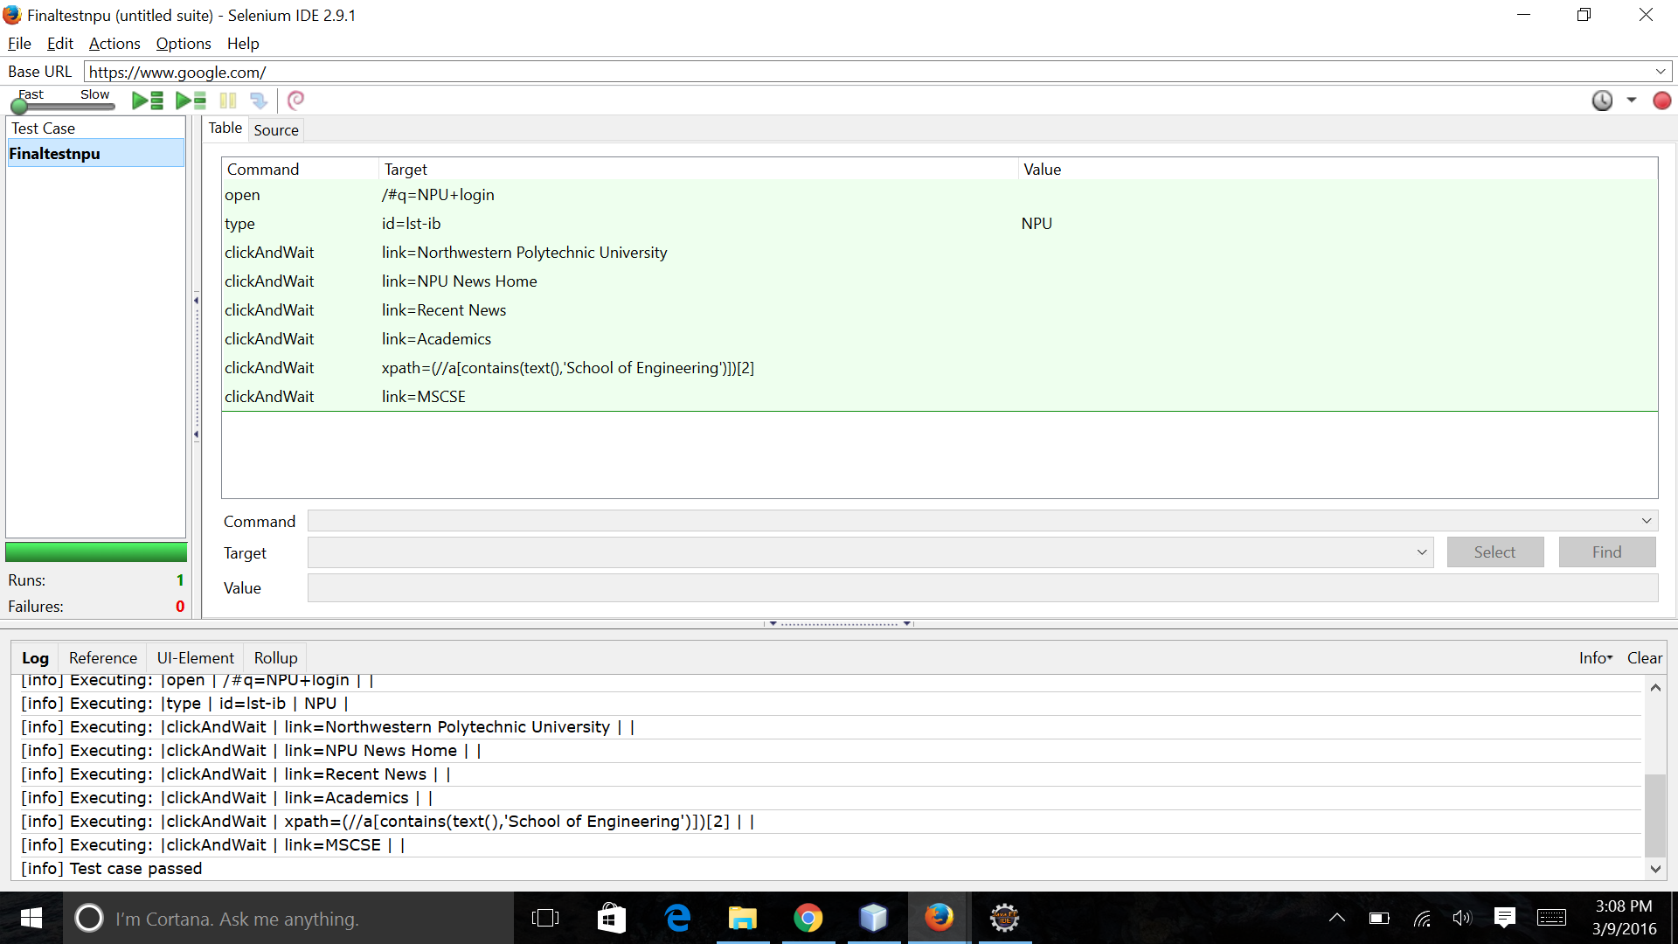

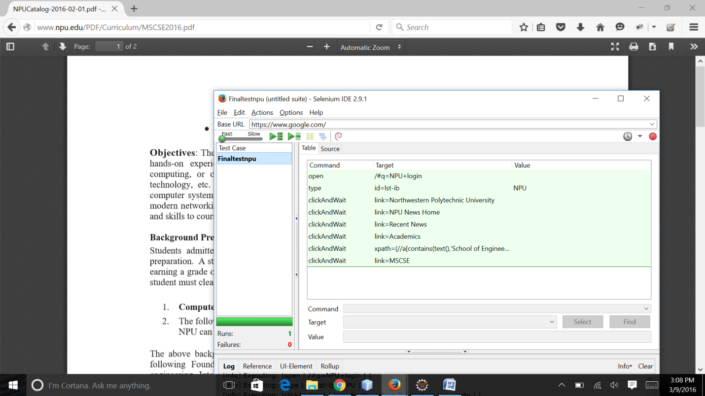

import java.util.regex.Pattern;

import java.util.concurrent.TimeUnit;

import org.junit.*;

import static org.junit.Assert.*;

import static org.hamcrest.CoreMatchers.*;

import org.openqa.selenium.*;

import org.openqa.selenium.firefox.FirefoxDriver;

import org.openqa.selenium.support.ui.Select;

public class Testcasenpuwebsite {

private WebDriver driver;

private String baseUrl;

private boolean acceptNextAlert = true;

private StringBuffer verificationErrors = new StringBuffer();

@Before

public void setUp() throws Exception {

driver = new FirefoxDriver();

baseUrl = "https://www.google.com/";

driver.manage().timeouts().implicitlyWait(30, TimeUnit.SECONDS);

}

@Test

public void testProject() throws Exception {

driver.get(baseUrl + "/#q=NPU+login");

driver.findElement(By.id("lst-ib")).clear();

driver.findElement(By.id("lst-ib")).sendKeys("NPU");

driver.findElement(By.linkText("Northwestern Polytechnic University")).click();

driver.findElement(By.linkText("NPU News Home")).click();

driver.findElement(By.linkText("Recent News")).click();

driver.findElement(By.linkText("Academics")).click();

driver.findElement(By.xpath("(//a[contains(text(),'School of Engineering')])[2]")).click();

driver.findElement(By.linkText("MSCSE")).click();

}

@After

public void tearDown() throws Exception {

driver.quit();

String verificationErrorString = verificationErrors.toString();

if (!"".equals(verificationErrorString)) {

fail(verificationErrorString);

}

}

private boolean isElementPresent(By by) {

try {

driver.findElement(by);

return true;

} catch (NoSuchElementException e) {

return false;

}

}

private boolean isAlertPresent() {

try {

driver.switchTo().alert();

return true;

} catch (NoAlertPresentException e) {

return false;

}

}

private String closeAlertAndGetItsText() {

try {

Alert alert = driver.switchTo().alert();

String alertText = alert.getText();

if (acceptNextAlert) {

alert.accept();

} else {

alert.dismiss();

}

return alertText;

} finally {

acceptNextAlert = true;

}

}

}

